**CHAPTER 1**

**INTRODUCTION**

**1.1 INTRODUCTION**

An E-commerce website requires an appropriate strategy for successful design and implementation. Everything is required to plan from scratch to the end of the website. The e-commerce sector is seeing exponential growth thus a new option will easily be part of this regatta of commercial websites. The e-commerce website will feature an online shopping facility for various fashion products in a single webspace. The proposed web application will allow business personnel to make their total business using it and increase their reachability thousands of times more than today they have, over the internet. It will allow multiple shopping vendors to sell their products online. The product management in the system will be done in the form of categories. The safety of information is the main requirement of the system and will be handled according to that. To formulate this project the first task is to do cost estimation. For probabilistic assessment of the project cost estimation is required. Cost estimation covers the accurate; estimations of cost and effort required for the project. As a project manager and developer as well, its estimates are defined to an early stage in the project. Cost estimation in application development projects includes the set of procedures and techniques that will be utilised and required to produce by the organisation for development (Alex,2013). The available resources of a company are also affecting the cost estimation. It will be a very complex project. To demonstrate knowledge learnt in class, in tech communities and in online materials, I will undertake the entire project alone even though it requires a team of 6 or more. It will take 3 3months to get the shape or get the basic structure. The environment variants depend on the further requirements of the eCommerce web application.

The term was coined and first employed by Dr Robert Jacobson, Principal Consultant to the California State Assembly's Utilities & Commerce Committee, in the title and text of California's Electronic Commerce Act, carried by the late Committee Chairwoman Gwen Moore (D-L.A.) and enacted in 1984.

E-commerce typically uses the [web](https://en.wikipedia.org/wiki/World_Wide_Web) for at least a part of a transaction's life cycle although it may also use other technologies such as [e-mail](https://en.wikipedia.org/wiki/Email). Typical e-commerce transactions include the purchase of products (such as books from [Amazon](https://en.wikipedia.org/wiki/Amazon_(company))) or services (such as [music downloads](https://en.wikipedia.org/wiki/Music_download) in the form of [digital distribution](https://en.wikipedia.org/wiki/Digital_distribution) such as [iTunes Store](https://en.wikipedia.org/wiki/ITunes_Store)).[[1]](https://en.wikipedia.org/wiki/E-commerce#cite_note-1) There are three areas of e-commerce: [online retailing](https://en.wikipedia.org/wiki/Online_retailing), [electronic markets](https://en.wikipedia.org/wiki/Electronic_markets), and [online auctions](https://en.wikipedia.org/wiki/Online_auction). E-commerce is supported by [electronic business](https://en.wikipedia.org/wiki/Electronic_business).[[2]](https://en.wikipedia.org/wiki/E-commerce#cite_note-2) The existence value of e-commerce is to allow consumers to shop online and pay online through the Internet, saving them time and space for customers and enterprises, greatly improving transaction efficiency, especially for busy office workers, but also saving a lot of valuable time.[[3]](https://en.wikipedia.org/wiki/E-commerce#cite_note-3)

E-commerce businesses may also employ some or all of the following:

* [Online shopping](https://en.wikipedia.org/wiki/Online_shopping) for [retail sales direct](https://en.wikipedia.org/wiki/Direct_selling) to consumers via websites and [mobile apps](https://en.wikipedia.org/wiki/Mobile_apps), and [conversational commerce](https://en.wikipedia.org/wiki/Conversational_commerce) via [live chat](https://en.wikipedia.org/wiki/Live_chat), [chatbots](https://en.wikipedia.org/wiki/Chatbot), and [voice assistants](https://en.wikipedia.org/wiki/Voice_assistants);[[4]](https://en.wikipedia.org/wiki/E-commerce#cite_note-venturebeat.com-4)
* Providing or participating in [online marketplaces](https://en.wikipedia.org/wiki/Online_marketplace), which process third-party [business-to-consumer](https://en.wikipedia.org/wiki/Business-to-consumer) (B2C) or [consumer-to-consumer](https://en.wikipedia.org/wiki/Consumer-to-consumer) (C2C) sales;
* [Business-to-business (B2B)](https://en.wikipedia.org/wiki/B2B_e-commerce) buying and selling;[[5]](https://en.wikipedia.org/wiki/E-commerce#cite_note-5)
* Gathering and using demographic data through web contacts and social media;
* B2B [electronic data interchange](https://en.wikipedia.org/wiki/Electronic_data_interchange);
* Marketing to prospective and established [customers](https://en.wikipedia.org/wiki/Customer) by [e-mail](https://en.wikipedia.org/wiki/Email_marketing) or fax (for example, with [newsletters](https://en.wikipedia.org/wiki/Newsletter));
* Engaging in retail for launching new products and services;
* Online financial exchanges for currency exchanges or trading purposes.

**1.2 PROBLEM STATEMENT**

Traditionally, customers are used to buying the products at the real, in other words, factual shops or supermarkets. It needs the customers to show up in the shops in person, and walk around different shopping shelves, and it also needs the owners of shops to stock, exhibit, and transfer the products required by customers. It takes labour, time and space to process these operations. Furthermore, the spread of the Covid-19 pandemic has caused a lot of changes in our lifestyle, people fearing to get outside their homes, transportation almost shut down and social distancing becoming all the more important. Big to small scale businesses that relied on the traditional incur a lot of consequences due to the lockdown issues. Some tend to be more towards using social media platforms like Facebook to sell their product. However, the social media platforms have been beneficial for marketing purposes alone but leave the whole task of the customer and massive order management via direct messaging (DM), which takes a lot of time to respond to all customers. In addition, everyone tends to use social media, posing a great challenge to differentiate between scammers (fraudsters) and legit sellers.

**1.3 THE SOLUTION**

La BELLE Fashions Store is an Online shopping system that provides a solution to reduce and optimise these expenses. Authorised Customers do not need to go to the factual shops to choose, and bring the products they need by hand. They simply browse their Personal computers or cell phones to access shops and evaluate the product description, and pictures on the screen to choose products. In addition, the owners of the shop do not need to arrange or exhibit their stock products. They just input the description, and prices of products, and upload their pictures. Simply, both customers and shop owners do not need to touch the real products in the whole process of shopping, and management. In the end, the logistic centre will distribute the products required by customers, or products ordered by shop owners to their locations. The customers can track the status of their orders until delivery, after which they can leave a review of the type of service they received. The payment and products’ quantity will be saved in the database through the data flow. These shopping, management and distribution processes greatly simplify and optimise the retail business.

**1.4 SCOPE**

Every project is done to achieve a set of goals with some conditions keeping in mind that it should be easy to use, feasible and user friendly. As the goal of this project is to develop an online fashion brochure system, this system will be designed keeping in mind the conditions (easy to use, feasibility and user friendly) stated above. It may help in effective and efficient order management. In every short time, the collection will be obvious, simple and sensible. It is very possible to observe the customer potential and purchase patterns because all the ordering history is stored in the database. It is efficient in managing all the operations of an online store within a single platform. The project aims to automate the business process of shopping stores.

**CHAPTER 2**

**REQUIREMENTS**

**2.1 SOFTWARE REQUIREMENTS**

* Python
* python-Django
* My-Sqlite
* Windows/Linux/macOS

**2.2 HARDWARE REQUIREMENTS**

* Intel Pentium IV processor or equivalent or higher
* 512 MB Ram or Higher
* 20 GB HDD or Higher
* Network Connectivity

**2.3 TECHNOLOGIES USED**

### Front-end ( HTML,CSS, JavaScript)

* + HTML:
    - The **HyperText Markup Language** or **HTML** is the standard [markup language](https://en.wikipedia.org/wiki/Markup_language) for documents designed to be displayed in a [web browser](https://en.wikipedia.org/wiki/Web_browser). It can be assisted by technologies such as [Cascading Style Sheets](https://en.wikipedia.org/wiki/Cascading_Style_Sheets) (CSS) and [scripting languages](https://en.wikipedia.org/wiki/Scripting_language) such as [JavaScript](https://en.wikipedia.org/wiki/JavaScript).
    - [Web browsers](https://en.wikipedia.org/wiki/Web_browser) receive HTML documents from a [web server](https://en.wikipedia.org/wiki/Web_server) or from local storage and [render](https://en.wikipedia.org/wiki/Browser_engine) the documents into multimedia web pages. HTML describes the structure of a [web page](https://en.wikipedia.org/wiki/Web_page) [semantically](https://en.wikipedia.org/wiki/Semantic_Web) and originally included cues for the appearance of the document.
    - [HTML elements](https://en.wikipedia.org/wiki/HTML_element) are the building blocks of HTML pages. With HTML constructs, [images](https://en.wikipedia.org/wiki/HTML_element#Images_and_objects) and other objects such as [interactive forms](https://en.wikipedia.org/wiki/Fieldset) may be embedded into the rendered page. HTML provides a means to create [structured documents](https://en.wikipedia.org/wiki/Structured_document) by denoting structural [semantics](https://en.wikipedia.org/wiki/Semantics) for text such as headings, paragraphs, lists, [links](https://en.wikipedia.org/wiki/Hyperlink), quotes and other items. HTML elements are delineated by *tags*, written using [angle brackets](https://en.wikipedia.org/wiki/Bracket#Angle_brackets). Tags such as <**img** /> and <**input** /> directly introduce content into the page. Other tags such as <**p**> surround and provide information about document text and may include other tags as sub-elements. Browsers do not display the HTML tags but use them to interpret the content of the page.
  + CSS:
    - **Cascading Style Sheets** (**CSS**) is a [style sheet language](https://en.wikipedia.org/wiki/Style_sheet_language) used for describing the [presentation](https://en.wikipedia.org/wiki/Presentation_semantics) of a document written in a [markup language](https://en.wikipedia.org/wiki/Markup_language) such as [HTML](https://en.wikipedia.org/wiki/HTML). CSS is a cornerstone technology of the [World Wide Web](https://en.wikipedia.org/wiki/World_Wide_Web), alongside HTML and [JavaScript](https://en.wikipedia.org/wiki/JavaScript).
    - CSS is designed to enable the separation of presentation and content, including [layout](https://en.wikipedia.org/wiki/Page_layout), colours, and [fonts](https://en.wikipedia.org/wiki/Typeface). This separation can improve content [accessibility](https://en.wikipedia.org/wiki/Accessibility); provide more flexibility and control in the specification of presentation characteristics; enable multiple [web pages](https://en.wikipedia.org/wiki/Web_page) to share formatting by specifying the relevant CSS in a separate .css file, which reduces complexity and repetition in the structural content; and enable the .css file to be [cached](https://en.wikipedia.org/wiki/Cache_(computing)) to improve the page load speed between the pages that share the file and its formatting.
    - Separation of formatting and content also makes it feasible to present the same markup page in different styles for different rendering methods, such as on-screen, in print, by voice (via speech-based browser or [screen reader](https://en.wikipedia.org/wiki/Screen_reader)), and on [Braille-based](https://en.wikipedia.org/wiki/Braille_display) tactile devices. CSS also has rules for alternate formatting if the content is accessed on a [mobile device](https://en.wikipedia.org/wiki/Mobile_device).
  + JAVASCRIPT:
    - **JavaScript** often abbreviated **JS**, is a [programming language](https://en.wikipedia.org/wiki/Programming_language) that is one of the core technologies of the [World Wide Web](https://en.wikipedia.org/wiki/World_Wide_Web), alongside [HTML](https://en.wikipedia.org/wiki/HTML) and [CSS](https://en.wikipedia.org/wiki/CSS). Over 97% of [websites](https://en.wikipedia.org/wiki/Website) use JavaScript on the client-side for [web page](https://en.wikipedia.org/wiki/Web_page) behaviour, often incorporating third-party [libraries](https://en.wikipedia.org/wiki/Library_(computing)). All major [web browsers](https://en.wikipedia.org/wiki/Web_browser) have a dedicated [JavaScript engine](https://en.wikipedia.org/wiki/JavaScript_engine) to execute the [code](https://en.wikipedia.org/wiki/Source_code) on [users](https://en.wikipedia.org/wiki/User_(computing))' devices.
    - JavaScript is a [high-level](https://en.wikipedia.org/wiki/High-level_programming_language), often [just-in-time compiled](https://en.wikipedia.org/wiki/Just-in-time_compilation) language that conforms to the [ECMAScript](https://en.wikipedia.org/wiki/ECMAScript) standard. It has [dynamic typing](https://en.wikipedia.org/wiki/Dynamic_typing), [prototype-based](https://en.wikipedia.org/wiki/Prototype-based_programming) object orientation, and [first-class functions](https://en.wikipedia.org/wiki/First-class_function). It is [multi-paradigm](https://en.wikipedia.org/wiki/Programming_paradigm), supporting [event-driven](https://en.wikipedia.org/wiki/Event-driven_programming), [functional](https://en.wikipedia.org/wiki/Functional_programming), and [imperative](https://en.wikipedia.org/wiki/Imperative_programming) [programming styles](https://en.wikipedia.org/wiki/Programming_paradigm). It has [application programming interfaces](https://en.wikipedia.org/wiki/Application_programming_interface) (APIs) for working with text, dates, [regular expressions](https://en.wikipedia.org/wiki/Regular_expression), standard [data structures](https://en.wikipedia.org/wiki/Data_structure), and the [Document Object Model](https://en.wikipedia.org/wiki/Document_Object_Model) (DOM).
    - The ECMAScript standard does not include any [input/output](https://en.wikipedia.org/wiki/Input/output) (I/O), such as [networking](https://en.wikipedia.org/wiki/Computer_network), [storage](https://en.wikipedia.org/wiki/Data_storage), or [graphics](https://en.wikipedia.org/wiki/Computer_graphics) facilities. In practice, the web browser or other [runtime system](https://en.wikipedia.org/wiki/Runtime_system) provides JavaScript APIs for I/O.

### Backend (Python-Django):

Python Django is a web framework that allows to quickly create efficient web pages. Django is also called batteries included framework because it provides built-in features such as Django Admin Interface, default database – SQLite3, etc. When you’re building a website, you always need a similar set of components: a way to handle user authentication (signing up, signing in, signing out), a management panel for your website, forms, a way to upload files, etc. Django gives you ready-made components to use.

#### Why Django FrameWork?

* Excellent documentation and high scalability.
* Used by Top MNCs and Companies, such as Instagram, Disqus, Spotify, Youtube, Bitbucket, Dropbox, etc. and the list is never-ending.

#### Django Architecture:

* Model: The model is going to act as the interface of your data. It is responsible for maintaining data. It is the logical data structure behind the entire application and is represented by a database (generally relational databases such as MySql, or Postgres).
* View: The View is the user interface that you see in your browser when you render a website. It is represented by HTML/CSS/Javascript and Jinja files.
* Template: A template consists of static parts of the desired HTML output as well as some special syntax describing how dynamic content will be inserted. To check more, visit – Django Templates

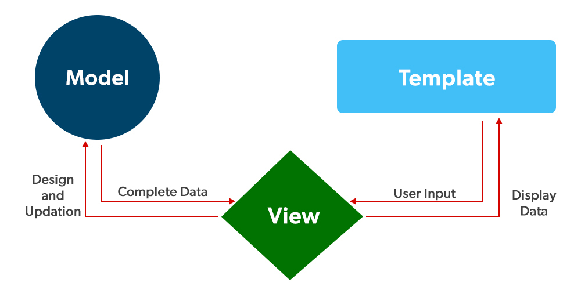

### Database(Mysql-Lite):

* + **SQLite** is a [database engine](https://en.wikipedia.org/wiki/Database_engine) written in the [C language](https://en.wikipedia.org/wiki/C_Language). It is not a standalone app; rather, it is a [library](https://en.wikipedia.org/wiki/Library_(computing)) that [software developers](https://en.wikipedia.org/wiki/Programmer) embed in their apps. As such, it belongs to the family of [embedded databases](https://en.wikipedia.org/wiki/Embedded_database). It is the most widely deployed database engine, as it is used by several of the top [web browsers](https://en.wikipedia.org/wiki/Web_browser), [operating systems](https://en.wikipedia.org/wiki/Operating_system), [mobile phones](https://en.wikipedia.org/wiki/Mobile_phone), and other [embedded systems](https://en.wikipedia.org/wiki/Embedded_system).
  + SQLite has [bindings](https://en.wikipedia.org/wiki/Language_binding) to many [programming languages](https://en.wikipedia.org/wiki/Programming_language). It generally follows [PostgreSQL](https://en.wikipedia.org/wiki/PostgreSQL) syntax but does not enforce [type checking](https://en.wikipedia.org/wiki/Type_checking). This means that one can, for example, insert a string into a [column](https://en.wikipedia.org/wiki/Column_(database)) defined as an integer.
  + SQLite implements most of the [SQL-92](https://en.wikipedia.org/wiki/SQL-92) standard for SQL but lacks some features. For example, it only partially provides [triggers](https://en.wikipedia.org/wiki/Database_trigger) and cannot write to [views](https://en.wikipedia.org/wiki/View_(database)) (however, it provides INSTEAD OF triggers that provide this functionality). Its support of [ALTER TABLE](https://en.wikipedia.org/wiki/Data_Definition_Language#ALTER_statements) statements is limited.
  + SQLite uses an unusual [type system](https://en.wikipedia.org/wiki/Type_system) for a SQL-compatible DBMS: instead of assigning a [type](https://en.wikipedia.org/wiki/SQL_data_types) to a column as in most SQL database systems, types are assigned to individual values; in language terms, it is *dynamically typed*. Moreover, it is *weakly typed* in some of the same ways that [Perl](https://en.wikipedia.org/wiki/Perl) is: one can insert a [string](https://en.wikipedia.org/wiki/String_(computer_science)) into an [integer](https://en.wikipedia.org/wiki/Integer_(computer_science)) column (although SQLite will try to convert the string to an integer first if the column's preferred type is an integer). This adds flexibility to columns, especially when bound to a dynamically typed scripting language. However, the technique is not portable to other SQL products. A common criticism is that SQLite's type system lacks the data integrity mechanism provided by statically typed columns in other products. The SQLite website describes a "strict affinity" mode, but this feature has not yet been added. However, it can be implemented with constraints like CHECK(typeof(x)='integer').
  + Tables normally include a hidden *row id* index column, which gives faster access. If a database includes an Integer Primary Key column, SQLite will typically optimize it by treating it as an alias for *row id*, causing the contents to be stored as a [strictly typed](https://en.wikipedia.org/wiki/Strictly_typed) 64-bit signed integer and changing its behaviour to be somewhat like an auto-incrementing column. Future versions of SQLite may include a command to introspect whether a column has a behaviour like that of *rowid* to differentiate these columns from weakly typed, non-autoincrementing Integer Primary Keys.

**CHAPTER 3**

**EXISTING WORK**

**3.1 INTRODUCTION TO EXISTING WORK**

Online buying behaviour is affected by various factors like economic factors, demographic factors, technical factors, social factors, cultural factors, psychological factors, marketing factors and legislative factors. Customers choose an online shop mainly based on references, clarity terms of delivery, graphic design and additional services. Problematic customers read discussions on the Internet before they spend their money online and when customers are incapable to purchase the product fast and with no trouble they leave online-shop. Kotler, (2003) described the Consumer buying method as a learning, information-processing and decision-making activity divided into several consequent steps: Problem identification, Information search, Alternatives evaluation, Purchasing decision, and Post-purchase behaviour. Euthymia identified the main constituent of the online shopping experience as follows: the functionality of the Web site that includes the elements trade with the site’s usability. the emotional elements planned for lowering the customer’s hesitation by communicating trust and credibility of the online seller and Web site and the content elements include the aesthetic aspects of the online presentation and the marketing mix. Usability and trust are the issues more regularly found to influence the online consumer’s behaviour. Karayiannis, (2 examined the discrimination of potential determinants between web- shoppers and non-shoppers. Free shipping is a great motivator to purchase the products and customers are willing to pay nominal charges for getting their products. While comparing the shopping with other shopping, consumers take product price and shipping charges almost equally into deliberation. There are some ways that retailers can improve the experience for their online shoppers. The first is to write the expected delivery date of the order, customers are willing to wait for their orders but want to know just how long that force is. The timely coming of product shipment encourages shoppers to recommend an online retailer. Consumers also want to track updates and delivery notifications to understand when their package is incoming. Online shoppers want flexibility in their shipping, mainly the ability to give special delivery instructions or schedule a delivery time. Customers are also wanting to get the address changing option for filling the wrong address when they are purchasing online.

**3.2 METHODOLOGY**

**3.2.1 INTRODUCTION**

This section describes the methodology applied during the development of the Shopping store. A methodology is a model, which project managers employ for the design, planning, implementation and achievement of their project objectives. Effective project management is essential in absolutely any organisation, regardless of the nature of the business and the scale of the organisation. From choosing a project right through to the end, it is important that the project is carefully and closely managed. Based on the nature of my project solution, it was essential to use an incremental Software development life cycle (SDLC). The project typically has a number of Phases and the level of control required over each phase is primarily defined by the nature of the project, its complexity of the same and the industry to which the Project has to cater. An Incremental (SDLC) model consists of a number of dependent increments that are completed in a prescribed sequence. Each increment includes a Launching, Monitoring and Controlling, and Closing Process Group for the functions and features in that increment only. Each increment integrates additional parts of the solution until the final increment, where the remaining parts of the solution are integrated.

**A. PROJECT MANAGEMENT LIFECYCLE**

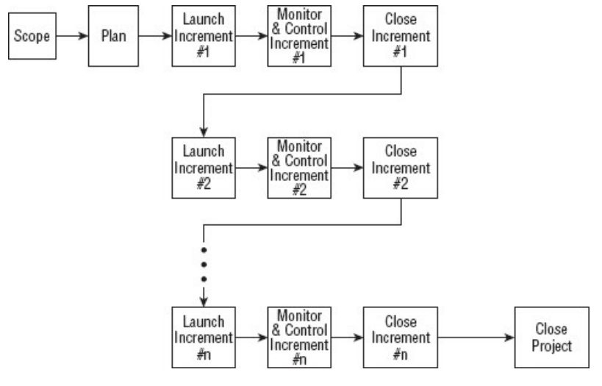

**3.3 ARCHITECTURE**

**3.3.1 SYSTEM DESIGN**

The section describes the system study, analysis, design strengths and weaknesses of the current system, Contest level diagrams, Entity Relationship Diagram, and Architectural design. After interpretation of the data, tables were drawn and the process of data was determined to guide the researcher in the implementation stage of the project. The tools, which were employed during this 32 methodology stage, were mainly tables, Data Flow Diagrams and Entity Relationship Diagrams. The design ensures that only authorized users access the system's information.

1. **PROCESS FLOW**

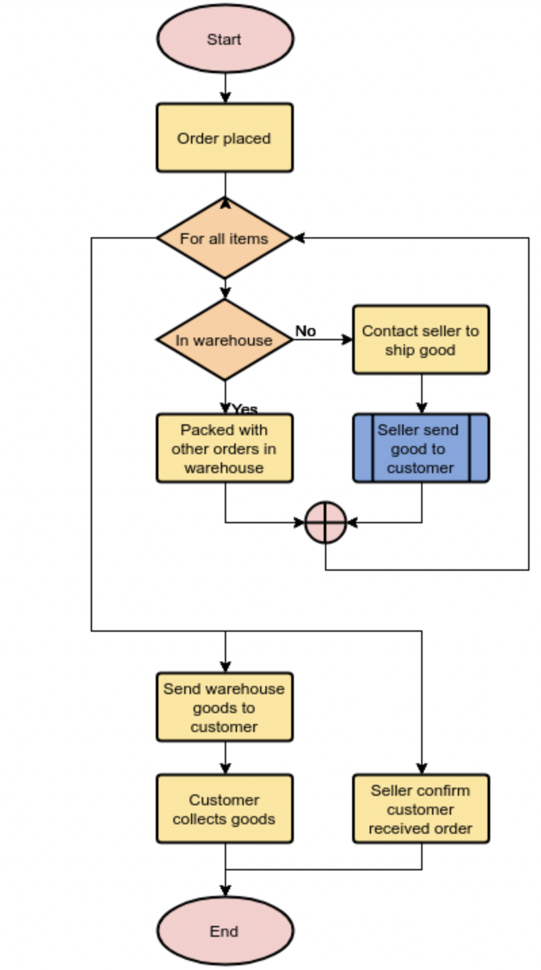

1. **DATAFLOW DIAGRAM**

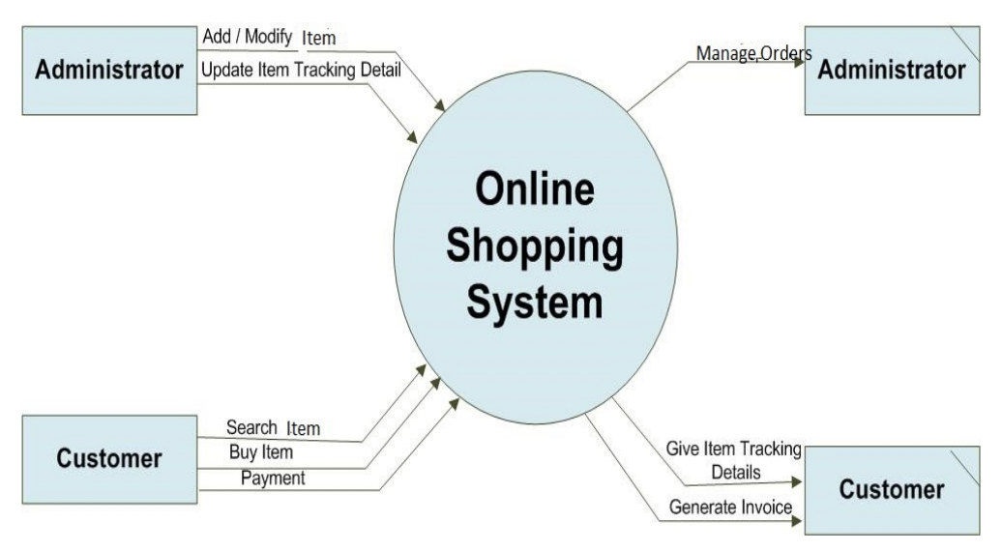

1. **FLOW CHART**

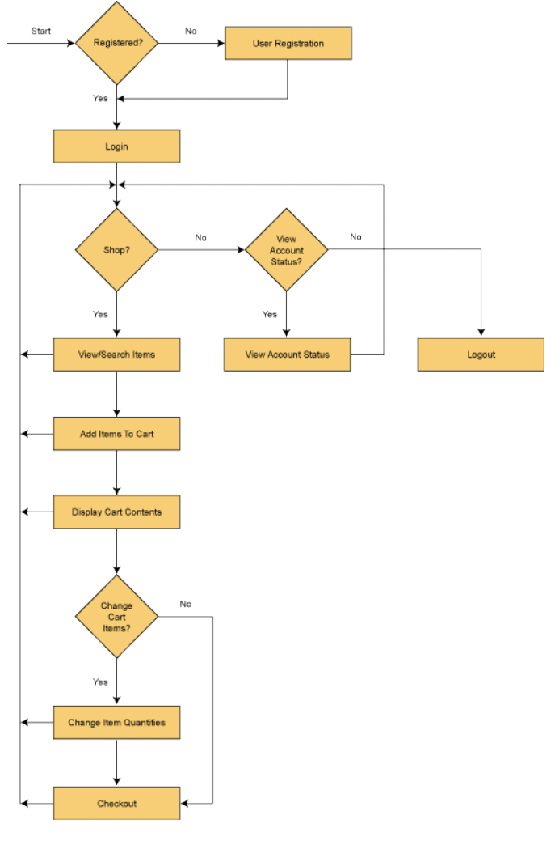

**CHAPTER 4**

**PROJECT SNAPSHOT**

**6.1 HOME PAGE**

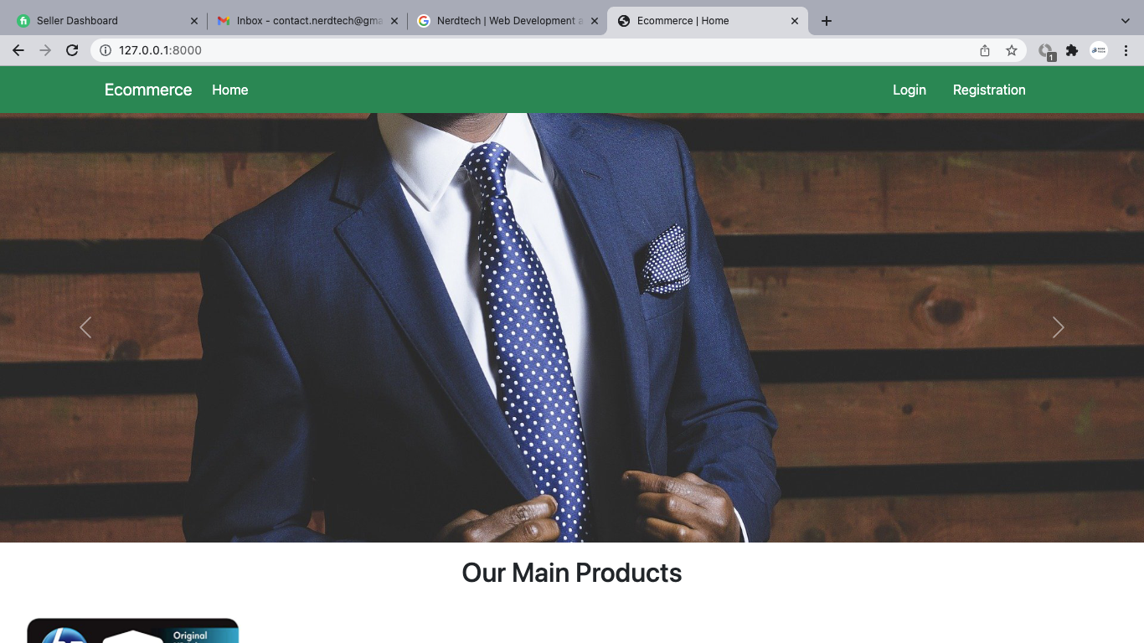

**6.2 LOGIN PAGE**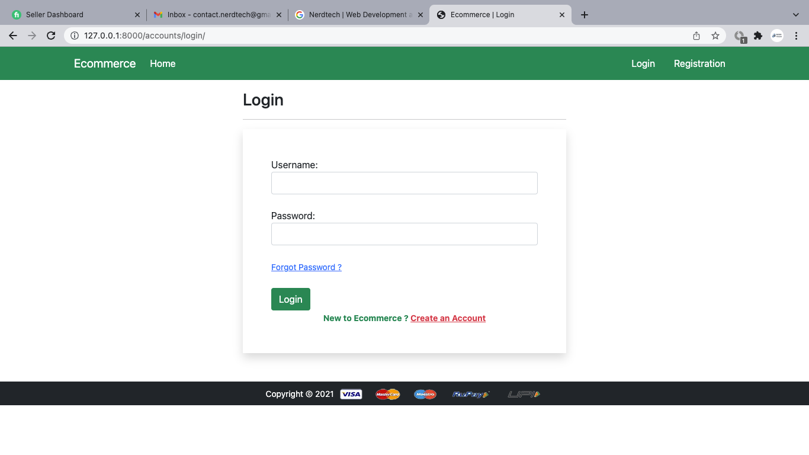

**6.3 SIGNUP PAGE**

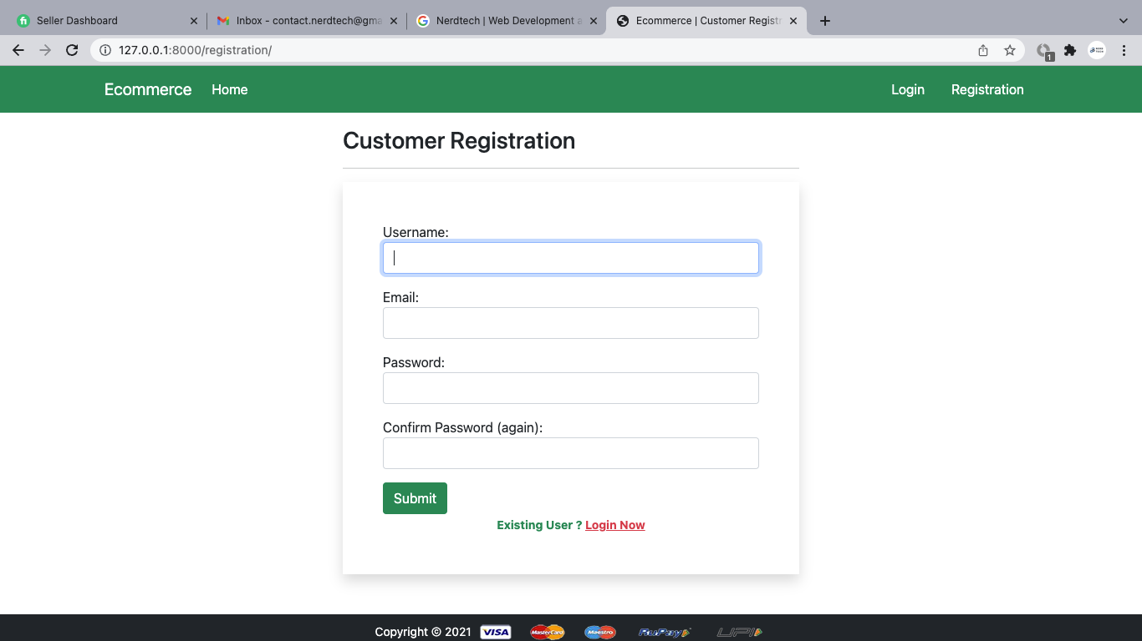

**6.4 PRODUCT DETAILS**

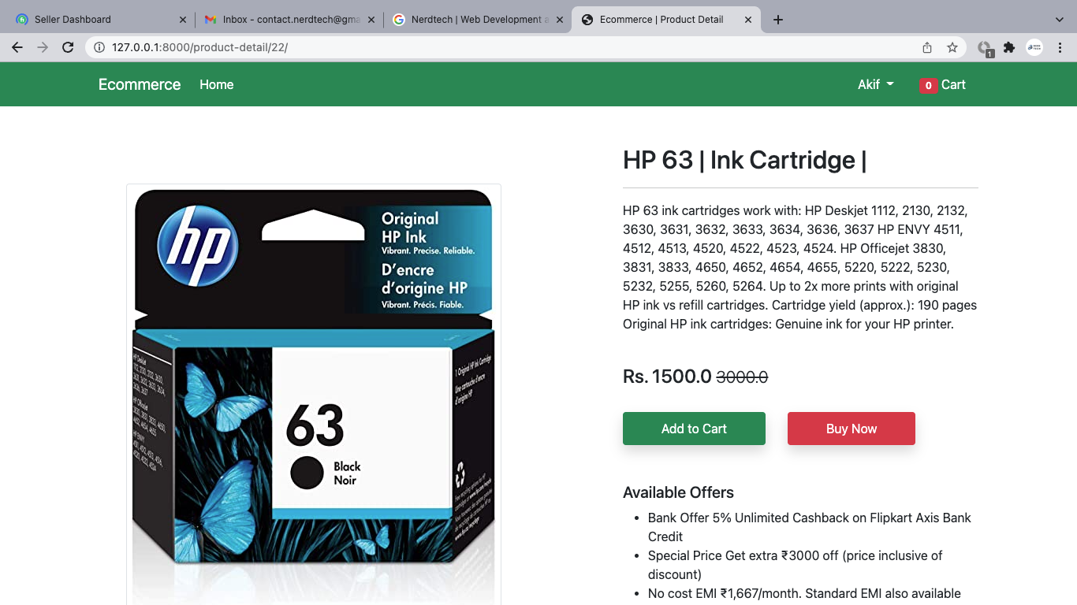

**6.5 CART PAGE**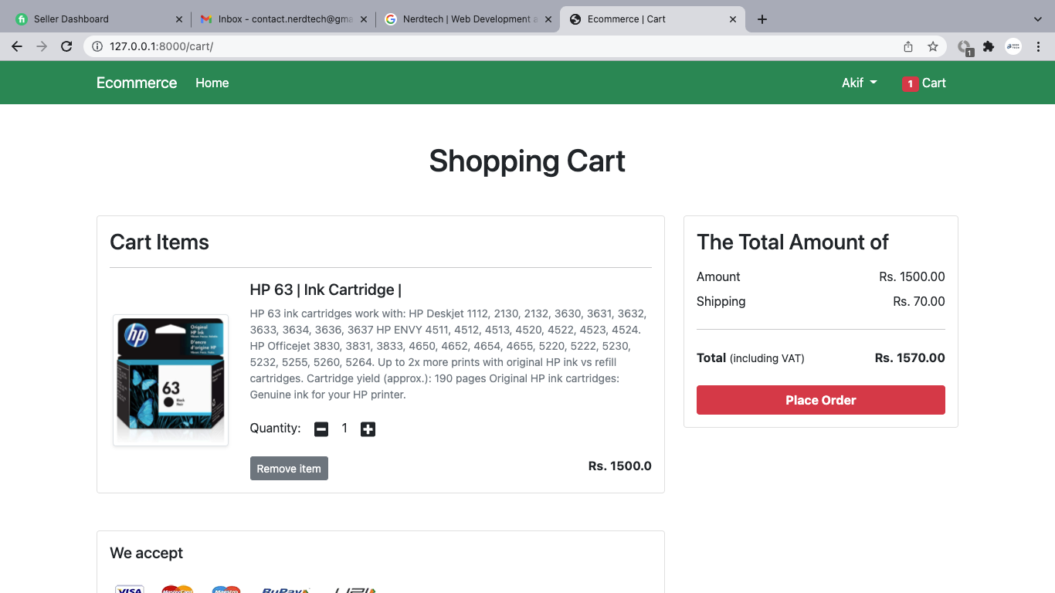

**6.6 DATABASE TABLE FOR THE ADDRESS PART**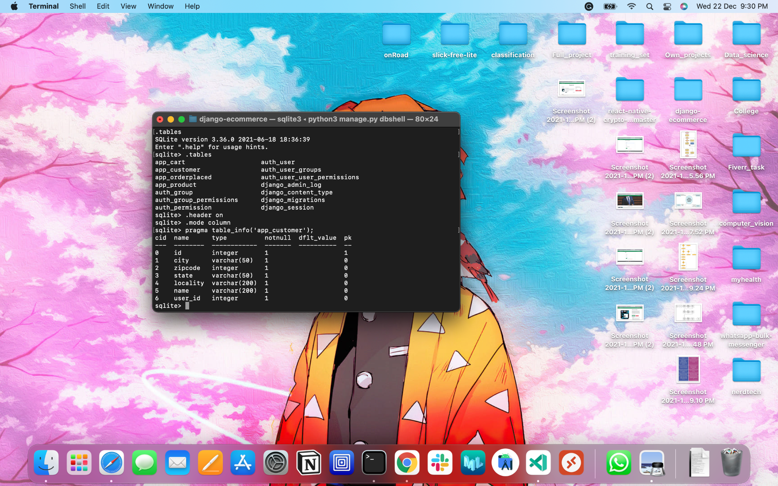

**CHAPTER 5**

**CONCLUSION**

The project entitled Ecommerce Store system was completed successfully. The system has been developed with much care and is free of errors and at the same time, it is efficient and less time-consuming. The purpose of this project was to develop a web application for purchasing items from a fashion shop. This project enabled me to gain valuable information and practical knowledge on several topics like designing web pages using HTML & CSS, usage of responsive templates, designing full-stack Django applications, and management of databases using SQLite 3. The entire system is secured. Also, the project helped me understand the development phases of a project and the software development life cycle. I learned how to test different features of a project. This project has given me great satisfaction in having designed an application that can be implemented in any nearby shops or branded shops selling various kinds of products with simple modifications. However, it was very challenging to learn and develop an application using a new technology